Java Design Patterns

Design patterns represent the best practices used by experienced object-oriented software developers. Design patterns are solutions to general problems that software developers faced during software development. These solutions were obtained by trial and error by numerous software developers over quite a substantial period of time.
Design Patterns are already defined and provides industry standard approach to solve a recurring problem, so it saves time if we sensibly use the design pattern.
Using design patterns promotes reusability that leads to more robust and highly maintainable code. It helps in reducing total cost of ownership (TCO) of the software product.
- What is Gang of Four (GOF)?
In 1994, four authors Erich Gamma, Richard Helm, Ralph Johnson and John Vlissides published a book titled Design Patterns - Elements of Reusable Object-Oriented Software which initiated the concept of Design Pattern in Software development.
These authors are collectively known as Gang of Four (GOF). According to these authors design patterns are primarily based on the following principles of object orientated design.
- Program to an interface not an implementation
- Favor object composition over inheritance
- Types of Design Patterns

1 | Creational Patterns  These design patterns provide a way to create objects while hiding the creation logic, rather than instantiating objects directly using new operator. This gives program more flexibility in deciding which objects need to be created for a given use case.  - Singleton Pattern  - Factory Pattern  - Abstract Factory Pattern  - Builder Pattern  - Prototype Pattern
2 | Structural Patterns  These design patterns concern class and object composition. Concept of inheritance is used to compose interfaces and define ways to compose objects to obtain new functionalities.  - Adapter Pattern  - Bridge Pattern  - Composite Pattern  - Decorator Pattern  - Flyweight Pattern  - Facade Pattern  - Proxy Pattern
3 | Behavioral Patterns  These design patterns are specifically concerned with communication between objects.  - Template Method Pattern  - Mediator Pattern  - Chain of Responsibility Pattern  - Observer Pattern  - Strategy Pattern  - Command Pattern  - State Pattern  - Visitor Pattern  - Interpreter Pattern  - Iterator Pattern  - Memento Pattern
4 | J2EE Patterns  These design patterns are specifically concerned with the presentation tier. These patterns are identified by Sun Java Center.

1] Creational Patterns
a) Singleton Design Pattern: Define a class that has only one instance and provides a global point of access to it
- Singleton pattern restricts the instantiation of a class and ensures that only one instance of the class exists in the java virtual machine.
- The singleton class must provide a global access point to get the instance of the class.
- Singleton pattern is used for logging, driver’s objects, and caching and thread pool.
- Singleton design pattern is also used in other design patterns like Abstract Factory, Builder, Prototype, Facade etc.
- Singleton design pattern is used in core java classes also, for example java.lang.Runtime, java.awt.Desktop.
- How to create Singleton design pattern?
To create the singleton class, we need to have static member of class, private constructor and static factory method.
1] Static member: It gets memory only once because of static, it contains the instance of the Singleton class.
2] Private constructor: It will prevent to instantiate the Singleton class from outside the class.
3] Static factory method: This provides the global point of access to the Singleton object and returns the instance to the caller
- Example
1] JDBCSingleton.java
package com.test.singleton;

import java.sql.Connection;
import java.sql.DriverManager;
import java.sql.PreparedStatement;
import java.sql.ResultSet;
import java.sql.SQLException;

class JDBCSingleton {
// Step 1
// create a JDBCSingleton class.
// static member holds only one instance of the JDBCSingleton class.

private static JDBCSingleton jdbc;

// JDBCSingleton prevents the instantiation from any other class.
private JDBCSingleton() {
}

// Now we are providing gloabal point of access.
public static JDBCSingleton getInstance() {
if (jdbc == null) {
jdbc = new JDBCSingleton();
}
return jdbc;
}

// to get the connection from methods like insert, view etc.
private static Connection getConnection() throws ClassNotFoundException, SQLException {

Connection con = null;
Class.forName("com.mysql.jdbc.Driver");
con = DriverManager.getConnection("jdbc:mysql://localhost:3306/javadesignpatterns", "root", "");
return con;

}

// to insert the record into the database
public int insert(String name, String pass) throws SQLException {
Connection c = null;

PreparedStatement ps = null;

int recordCounter = 0;

try {

c = this.getConnection();
ps = c.prepareStatement("insert into userdata(uname,upassword)values(?,?)");
ps.setString(1, name);
ps.setString(2, pass);
recordCounter = ps.executeUpdate();

} catch (Exception e) {
e.printStackTrace();
} finally {
if (ps != null) {
ps.close();
}
if (c != null) {
c.close();
}
}
return recordCounter;
}

// to view the data from the database
public void view(String name) throws SQLException {
Connection con = null;
PreparedStatement ps = null;
ResultSet rs = null;

try {

con = this.getConnection();
ps = con.prepareStatement("select * from userdata where uname=?");
ps.setString(1, name);
rs = ps.executeQuery();
while (rs.next()) {
System.out.println("Name= " + rs.getString(2) + "\t" + "Paasword= " + rs.getString(3));

}

} catch (Exception e) {
System.out.println(e);
} finally {
if (rs != null) {
rs.close();
}
if (ps != null) {
ps.close();
}
if (con != null) {
con.close();
}
}
}

// to update the password for the given username
public int update(String name, String password) throws SQLException {
Connection c = null;
PreparedStatement ps = null;

int recordCounter = 0;
try {
c = this.getConnection();
ps = c.prepareStatement(" update userdata set upassword=? where uname='" + name + "' ");
ps.setString(1, password);
recordCounter = ps.executeUpdate();
} catch (Exception e) {
e.printStackTrace();
} finally {

if (ps != null) {
ps.close();
}
if (c != null) {
c.close();
}
}
return recordCounter;
}

// to delete the data from the database
public int delete(int userid) throws SQLException {
Connection c = null;
PreparedStatement ps = null;
int recordCounter = 0;
try {
c = this.getConnection();
ps = c.prepareStatement(" delete from userdata where uid='" + userid + "' ");
recordCounter = ps.executeUpdate();
} catch (Exception e) {
e.printStackTrace();
} finally {
if (ps != null) {
ps.close();
}
if (c != null) {
c.close();
}
}
return recordCounter;
}
}// End of JDBCSingleton class
2] JDBCSingletonDemo.java
package com.test.singleton;

import java.io.BufferedReader;
import java.io.IOException;
import java.io.InputStreamReader;

class JDBCSingletonDemo {
static int count = 1;
static int choice;

public static void main(String[] args) throws IOException {

JDBCSingleton jdbc = JDBCSingleton.getInstance();

BufferedReader br = new BufferedReader(new InputStreamReader(System.in));
do {
System.out.println("DATABASE OPERATIONS");
System.out.println(" --------------------- ");
System.out.println(" 1. Insertion ");
System.out.println(" 2. View ");
System.out.println(" 3. Delete ");
System.out.println(" 4. Update ");
System.out.println(" 5. Exit ");

System.out.print("\n");
System.out.print("Please enter the choice what you want to perform in the database: ");

choice = Integer.parseInt(br.readLine());
switch (choice) {

case 1: {
System.out.print("Enter the username you want to insert data into the database: ");
String username = br.readLine();
System.out.print("Enter the password you want to insert data into the database: ");
String password = br.readLine();

try {
int i = jdbc.insert(username, password);
if (i > 0) {
System.out.println((count++) + " Data has been inserted successfully");
} else {
System.out.println("Data has not been inserted ");
}

} catch (Exception e) {
System.out.println(e);
}

System.out.println("Press Enter key to continue...");
System.in.read();

} // End of case 1
break;
case 2: {
System.out.print("Enter the username : ");
String username = br.readLine();

try {
jdbc.view(username);
} catch (Exception e) {
System.out.println(e);
}
System.out.println("Press Enter key to continue...");
System.in.read();

} // End of case 2
break;
case 3: {
System.out.print("Enter the userid, you want to delete: ");
int userid = Integer.parseInt(br.readLine());

try {
int i = jdbc.delete(userid);
if (i > 0) {
System.out.println((count++) + " Data has been deleted successfully");
} else {
System.out.println("Data has not been deleted");
}

} catch (Exception e) {
System.out.println(e);
}
System.out.println("Press Enter key to continue...");
System.in.read();

} // End of case 3
break;
case 4: {
System.out.print("Enter the username, you want to update: ");
String username = br.readLine();
System.out.print("Enter the new password ");
String password = br.readLine();

try {
int i = jdbc.update(username, password);
if (i > 0) {
System.out.println((count++) + " Data has been updated successfully");
}

} catch (Exception e) {
System.out.println(e);
}
System.out.println("Press Enter key to continue...");
System.in.read();

} // end of case 4
break;

default:
return;
}

} while (choice != 4);
}
}

- Eager initialization
In eager initialization, the instance of Singleton Class is created at the time of class loading, this is the easiest method to create a singleton class but it has a drawback that instance is created even though client application might not be using it.
Here is the implementation of static initialization singleton class.
package com.journaldev.singleton;

public class EagerInitializedSingleton {

private static final EagerInitializedSingleton instance = new EagerInitializedSingleton();

//private constructor to avoid client applications to use constructor
private EagerInitializedSingleton(){}

public static EagerInitializedSingleton getInstance(){
return instance;
}
}
If your singleton class is not using a lot of resources, this is the approach to use. But in most of the scenarios, Singleton classes are created for resources such as File System, Database connections etc and we should avoid the instantiation until unless client calls the getInstance method. Also this method doesn’t provide any options for exception handling.
- Static block initialization
Static block initialization implementation is similar to eager initialization, except that instance of class is created in the static block that provides option for exception handling.
package com.journaldev.singleton;

public class StaticBlockSingleton {

private static StaticBlockSingleton instance;

private StaticBlockSingleton(){}

//static block initialization for exception handling
static{
try{
instance = new StaticBlockSingleton();
}catch(Exception e){
throw new RuntimeException("Exception occured in creating singleton instance");
}
}

public static StaticBlockSingleton getInstance(){
return instance;
}
}
Both eager initialization and static block initialization creates the instance even before it’s being used and that is not the best practice to use. So in further sections, we will learn how to create Singleton class that supports lazy initialization.
- Lazy Initialization
Lazy initialization method to implement Singleton pattern creates the instance in the global access method. Here is the sample code for creating Singleton class with this approach.
package com.journaldev.singleton;

public class LazyInitializedSingleton {

private static LazyInitializedSingleton instance;

private LazyInitializedSingleton(){}

public static LazyInitializedSingleton getInstance(){
if(instance == null){
instance = new LazyInitializedSingleton();
}
return instance;
}
}
The above implementation works fine incase of single threaded environment but when it comes to multithreaded systems, it can cause issues if multiple threads are inside the if loop at the same time. It will destroy the singleton pattern and both threads will get the different instances of singleton class. In next section, we will see different ways to create a thread-safe singleton class.

- Thread Safe Singleton
The easier way to create a thread-safe singleton class is to make the global access method synchronized, so that only one thread can execute this method at a time. General implementation of this approach is like the below class.
package com.journaldev.singleton;

public class ThreadSafeSingleton {

private static ThreadSafeSingleton instance;

private ThreadSafeSingleton(){}

public static synchronized ThreadSafeSingleton getInstance(){
if(instance == null){
instance = new ThreadSafeSingleton();
}
return instance;
}

}
Above implementation works fine and provides thread-safety but it reduces the performance because of cost associated with the synchronized method, although we need it only for the first few threads who might create the separate instances .To avoid this extra overhead every time, double checked locking principle is used. In this approach, the synchronized block is used inside the if condition with an additional check to ensure that only one instance of singleton class is created.
Below code snippet provides the double checked locking implementation.

public static ThreadSafeSingleton getInstanceUsingDoubleLocking(){
if(instance == null){
synchronized (ThreadSafeSingleton.class) {
if(instance == null){
instance = new ThreadSafeSingleton();
}
}
}
return instance;
}

b) Factory Design Pattern: Define an interface or abstract class for creating an object but let the subclasses decide which class to instantiate. In other words, subclasses are responsible to create the instance of the class.
The Factory Method Pattern is also known as Virtual Constructor.
Factory Method Pattern allows the sub-classes to choose the type of objects to create.
It promotes the loose-coupling by eliminating the need to bind application-specific classes into the code. That means the code interacts solely with the resultant interface or abstract class, so that it will work with any classes that implement that interface or that extends that abstract class.
When to use?
- When a class doesn't know what sub-classes will be required to create
- When a class wants that its sub-classes specify the objects to be created.
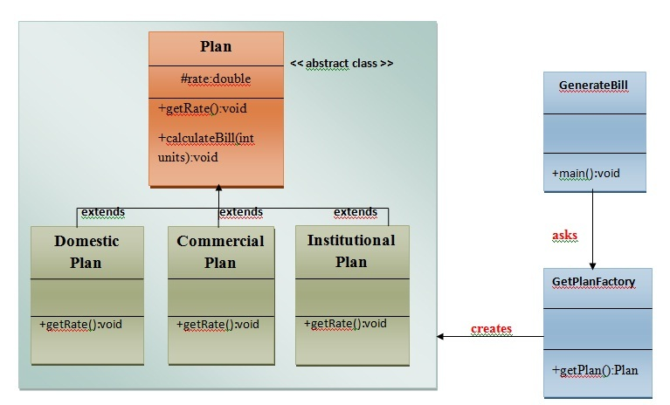
Example:
package com.test.designpatterns;

import java.io.*;

abstract class Plan {
protected double rate;

abstract void getRate();

public void calculateBill(int units) {
System.out.println(units * rate);
}
}

class DomesticPlan extends Plan {
public void getRate() {
rate = 3.50;
}
}

class CommercialPlan extends Plan {
public void getRate() {
rate = 7.50;
}
}

class InstitutionalPlan extends Plan {
public void getRate() {
rate = 5.50;
}
}

class GetPlanFactory {

// use getPlan method to get object of type Plan
public Plan getPlan(String planType) {
if (planType == null) {
return null;
}
if (planType.equalsIgnoreCase("DOMESTICPLAN")) {
return new DomesticPlan();
} else if (planType.equalsIgnoreCase("COMMERCIALPLAN")) {
return new CommercialPlan();
} else if (planType.equalsIgnoreCase("INSTITUTIONALPLAN")) {
return new InstitutionalPlan();
}
return null;
}
}

public class FactoryPattern {
public static void main(String args[]) throws IOException {
GetPlanFactory planFactory = new GetPlanFactory();

System.out.print("Enter the name of plan for which the bill will be generated: ");
BufferedReader br = new BufferedReader(new InputStreamReader(System.in));

String planName = br.readLine();
System.out.print("Enter the number of units for bill will be calculated: ");
int units = Integer.parseInt(br.readLine());

Plan p = planFactory.getPlan(planName);

System.out.print("Bill amount for " + planName + " of " + units + " units is: ");
p.getRate();
p.calculateBill(units);
}
}

c) Abstract Factory Design Pattern:
Define an interface or abstract class for creating families of related (or dependent) objects but without specifying their concrete sub-classes.
Abstract Factory Pattern is also known as Kit.

When to use?
- When the system needs to be independent of how its object are created, composed, and represented.
- When the family of related objects has to be used together, then this constraint needs to be enforced.
- When you want to provide a library of objects that does not show implementations and only reveals interfaces.
- When the system needs to be configured with one of a multiple family of objects.
Example:
- We are going to create a Bank interface and a Loan abstract class as well as their sub-classes.
- Then we will create AbstractFactory class as next step.
- Then after we will create concrete classes, BankFactory, and LoanFactory that will extends AbstractFactory class
- After that, AbstractFactoryPatternExample class uses the FactoryCreator to get an object of AbstractFactory class.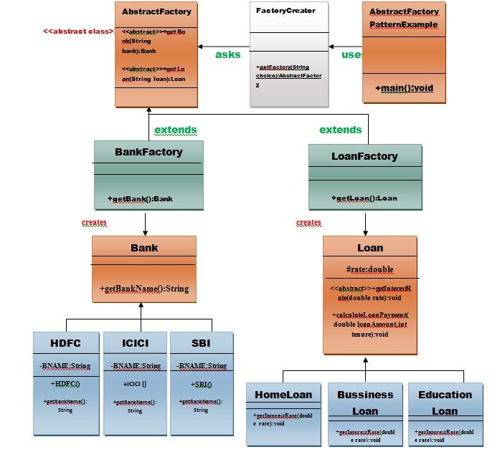

package com.test.designpatterns;

import java.io.*;

abstract class AbstractFactory {
public abstract Bank getBank(String bank);

public abstract Loan getLoan(String loan);
}

interface Bank {
String getBankName();
}

class HDFC implements Bank {
private final String BNAME;

public HDFC() {
BNAME = "HDFC BANK";
}

public String getBankName() {
return BNAME;
}
}

class ICICI implements Bank {
private final String BNAME;

ICICI() {
BNAME = "ICICI BANK";
}

public String getBankName() {
return BNAME;
}
}

class SBI implements Bank {
private final String BNAME;

public SBI() {
BNAME = "SBI BANK";
}

public String getBankName() {
return BNAME;
}
}

abstract class Loan {
protected double rate;

abstract void getInterestRate(double rate);

public void calculateLoanPayment(double loanamount, int years) {
/*
* to calculate the monthly loan payment i.e. EMI
*
* rate=annual interest rate/12*100; n=number of monthly installments;
* 1year=12 months. so, n=years*12;
*/

double EMI;
int n;

n = years * 12;
rate = rate / 1200;
EMI = ((rate * Math.pow((1 + rate), n)) / ((Math.pow((1 + rate), n)) - 1))
* loanamount;

System.out.println("your monthly EMI is " + EMI + " for the amount "
+ loanamount + " you have borrowed");
}
}// end of the Loan abstract class.

class HomeLoan extends Loan {
public void getInterestRate(double r) {
rate = r;
}
}

class BussinessLoan extends Loan {
public void getInterestRate(double r) {
rate = r;
}

}

class EducationLoan extends Loan {
public void getInterestRate(double r) {
rate = r;
}
}

class BankFactory extends AbstractFactory {
public Bank getBank(String bank) {
if (bank == null) {
return null;
}
if (bank.equalsIgnoreCase("HDFC")) {
return new HDFC();
} else if (bank.equalsIgnoreCase("ICICI")) {
return new ICICI();
} else if (bank.equalsIgnoreCase("SBI")) {
return new SBI();
}
return null;
}

public Loan getLoan(String loan) {
return null;
}
}// End of the BankFactory class.

class LoanFactory extends AbstractFactory {
public Bank getBank(String bank) {
return null;
}

public Loan getLoan(String loan) {
if (loan == null) {
return null;
}
if (loan.equalsIgnoreCase("Home")) {
return new HomeLoan();
} else if (loan.equalsIgnoreCase("Business")) {
return new BussinessLoan();
} else if (loan.equalsIgnoreCase("Education")) {
return new EducationLoan();
}
return null;
}

}

class FactoryCreator {
public static AbstractFactory getFactory(String choice) {
if (choice.equalsIgnoreCase("Bank")) {
return new BankFactory();
} else if (choice.equalsIgnoreCase("Loan")) {
return new LoanFactory();
}
return null;
}
}

public class AbstractFactoryPattern {
public static void main(String args[]) throws IOException {

BufferedReader br = new BufferedReader(new InputStreamReader(System.in));

System.out
.print("Enter the name of Bank from where you want to take loan amount: ");
String bankName = br.readLine();

System.out.print("\n");
System.out
.print("Enter the type of loan e.g. home loan or business loan or education loan : ");

String loanName = br.readLine();
AbstractFactory bankFactory = FactoryCreator.getFactory("Bank");
Bank b = bankFactory.getBank(bankName);

System.out.print("\n");
System.out.print("Enter the interest rate for " + b.getBankName()
+ ": ");

double rate = Double.parseDouble(br.readLine());
System.out.print("\n");
System.out.print("Enter the loan amount you want to take: ");

double loanAmount = Double.parseDouble(br.readLine());
System.out.print("\n");
System.out
.print("Enter the number of years to pay your entire loan amount: ");
int years = Integer.parseInt(br.readLine());

System.out.print("\n");
System.out.println("you are taking the loan from " + b.getBankName());

AbstractFactory loanFactory = FactoryCreator.getFactory("Loan");
Loan l = loanFactory.getLoan(loanName);
l.getInterestRate(rate);
l.calculateLoanPayment(loanAmount, years);
}
}

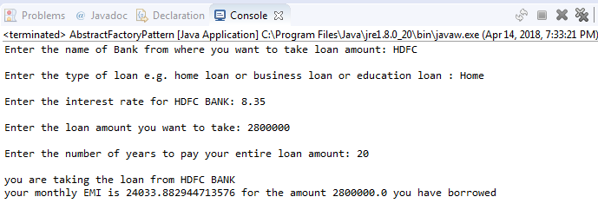

d) Prototype Design Pattern:
Prototype pattern refers to creating duplicate object while keeping performance in mind. This type of design pattern comes under creational pattern as this pattern provides one of the best ways to create an object.
This pattern involves implementing a prototype interface which tells to create a clone of the current object. This pattern is used when creation of object directly is costly. For example, an object is to be created after a costly database operation. We can cache the object, returns its clone on next request and update the database as and when needed thus reducing database calls.

Example:
We're going to create an abstract class Shape and concrete classes extending the Shape class. A class ShapeCache is defined as a next step which stores shape objects in a Hashtable and returns their clone when requested.
PrototypPatternDemo, our demo class will use ShapeCache class to get a Shape object.
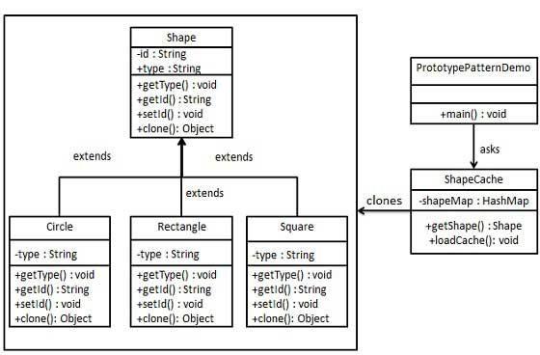

Step 1
Create an abstract class implementing Clonable interface.
Shape.java
public abstract class Shape implements Cloneable {
private String id;
protected String type;
abstract void draw();
public String getType(){
return type;
}
public String getId() {
return id;
}
public void setId(String id) {
this.id = id;
}
public Object clone() {
Object clone = null;
try {
clone = super.clone();
} catch (CloneNotSupportedException e) {
e.printStackTrace();
}
return clone;
}
}

Step 2
Create concrete classes extending the above class.
Rectangle.java
public class Rectangle extends Shape {
public Rectangle(){
type = "Rectangle";
}
@Override
public void draw() {
System.out.println("Inside Rectangle::draw() method.");
}
}
Square.java
public class Square extends Shape {
public Square(){
type = "Square";
}
@Override
public void draw() {
System.out.println("Inside Square::draw() method.");
}
}
Circle.java
public class Circle extends Shape {
public Circle(){
type = "Circle";
}
@Override
public void draw() {
System.out.println("Inside Circle::draw() method.");
}
}

Step 3
Create a class to get concrete classes from database and store them in a Hashtable.
ShapeCache.java
import java.util.Hashtable;
public class ShapeCache {
private static Hashtable<String, Shape> shapeMap = new Hashtable<String, Shape>();
public static Shape getShape(String shapeId) {
Shape cachedShape = shapeMap.get(shapeId);
return (Shape) cachedShape.clone();
}
// for each shape run database query and create shape
// shapeMap.put(shapeKey, shape);
// for example, we are adding three shapes
public static void loadCache() {
Circle circle = new Circle();
circle.setId("1");
shapeMap.put(circle.getId(),circle);
Square square = new Square();
square.setId("2");
shapeMap.put(square.getId(),square);
Rectangle rectangle = new Rectangle();
rectangle.setId("3");
shapeMap.put(rectangle.getId(), rectangle);
}
}

Step 4
PrototypePatternDemo uses ShapeCache class to get clones of shapes stored in a Hashtable.
PrototypePatternDemo.java
public class PrototypePatternDemo {
public static void main(String[] args) {
ShapeCache.loadCache();
Shape clonedShape = (Shape) ShapeCache.getShape("1");
System.out.println("Shape : " + clonedShape.getType());
Shape clonedShape2 = (Shape) ShapeCache.getShape("2");
System.out.println("Shape : " + clonedShape2.getType());
Shape clonedShape3 = (Shape) ShapeCache.getShape("3");
System.out.println("Shape : " + clonedShape3.getType());
}
}

Step 5
Verify the output.
Shape : Circle
Shape : Square
Shape : Rectangle

e) Builder Design Pattern:
Builder pattern was introduced to solve some of the problems with Factory and Abstract Factory design patterns when the Object contains a lot of attributes.
There are three major issues with Factory and Abstract Factory design patterns when the Object contains a lot of attributes.
- Too Many arguments to pass from client program to the Factory class that can be error prone because most of the time, the type of arguments are same and from client side it’s hard to maintain the order of the argument.
- Some of the parameters might be optional but in Factory pattern, we are forced to send all the parameters and optional parameters need to send as NULL.
- If the object is heavy and its creation is complex, then all that complexity will be part of Factory classes that is confusing.
We can solve the issues with large number of parameters by providing a constructor with required parameters and then different setter methods to set the optional parameters. The problem with this approach is that the Object state will be inconsistent until unless all the attributes are set explicitly.
- Builder pattern solves the issue with large number of optional parameters and inconsistent state by providing a way to build the object step-by-step and provide a method that will actually return the final Object.
- First of all you need to create a static nested class and then copy all the arguments from the outer class to the Builder class. We should follow the naming convention and if the class name is Computer then builder class should be named as ComputerBuilder.
- Java Builder class should have a public constructor with all the required attributes as parameters.
- Java Builder class should have methods to set the optional parameters and it should return the same Builder object after setting the optional attribute.
- The final step is to provide a build() method in the builder class that will return the Object needed by client program. For this we need to have a private constructor in the Class with Builder class as argument.
Here is the sample builder pattern example code where we have a Computer class and ComputerBuilder class to build it.

Example:
package com.test.designpatterns;

class Computer {

// required parameters
private String HDD;
private String RAM;

// optional parameters
private boolean isGraphicsCardEnabled;
private boolean isBluetoothEnabled;

public String getHDD() {
return HDD;
}

public String getRAM() {
return RAM;
}

public boolean isGraphicsCardEnabled() {
return isGraphicsCardEnabled;
}

public boolean isBluetoothEnabled() {
return isBluetoothEnabled;
}

private Computer(ComputerBuilder builder) {
this.HDD = builder.HDD;
this.RAM = builder.RAM;
this.isGraphicsCardEnabled = builder.isGraphicsCardEnabled;
this.isBluetoothEnabled = builder.isBluetoothEnabled;
}

// Builder Class
public static class ComputerBuilder {

// required parameters
private String HDD;
private String RAM;

// optional parameters
private boolean isGraphicsCardEnabled;
private boolean isBluetoothEnabled;

public ComputerBuilder(String hdd, String ram) {
this.HDD = hdd;
this.RAM = ram;
}

public ComputerBuilder setGraphicsCardEnabled(boolean isGraphicsCardEnabled) {
this.isGraphicsCardEnabled = isGraphicsCardEnabled;
return this;
}

public ComputerBuilder setBluetoothEnabled(boolean isBluetoothEnabled) {
this.isBluetoothEnabled = isBluetoothEnabled;
return this;
}

public Computer build() {
return new Computer(this);
}

}

}

public class BuilderPattern {

public static void main(String[] args) {
Computer comp = new Computer.ComputerBuilder("500 GB", "2 GB").setBluetoothEnabled(true)
.setGraphicsCardEnabled(true).build();
System.out.println("RAM="+comp.getRAM());
}
}
2] Structural Patterns
a) Adapter Design Pattern
Ever tried to use a your camera memory card in your laptop. You cannot use it directly simply because there is no port in laptop which accept it. You must use a compatible card reader. You put your memory card into card reader and then inject card reader into laptop. This card reader can be called adapter.
A similar example is your mobile charger or your laptop charger which can be used with any power supply without fear of the variance power supply in different locations. That is also called power “adapter”.
In programming as well, adapter pattern is used for similar purposes. It enable two incompatible interfaces to work smoothly with each other.
Adapter design pattern is one of the structural design pattern and its used so that two unrelated interfaces can work together. The object that joins these unrelated interface is called an Adapter.
An adapter pattern is also known as Wrapper pattern as well. Adapter Design is very useful for the system integration when some other existing components have to be adapted by the existing system without source code modifications.
The main use of this pattern is when a class that you need to use doesn’t meet the requirements of an interface. e.g. If you want to read the system input through command prompt in java then given below code is common way to do it:
BufferedReader br = new BufferedReader(new InputStreamReader(System.in));
System.out.print("Enter String");
String s = br.readLine();
System.out.print("Enter input: " + s);

Now here is the problem. System.in provides byte stream where BufferedReader expects character stream. InputStreamReader does exactly this thing and works adapter between System.in and BufferedReader.
3] Behavioral Patterns
a) Strategy Design Pattern
Strategy pattern is used when we have multiple algorithms for a specific task and client decides the actual implementation to be used at runtime.
Strategy pattern is also known as Policy Pattern. We define multiple algorithms and let client application pass the algorithm to be used as a parameter.
A simple Shopping Cart where we have two payment strategies – using Credit Card or using PayPal.
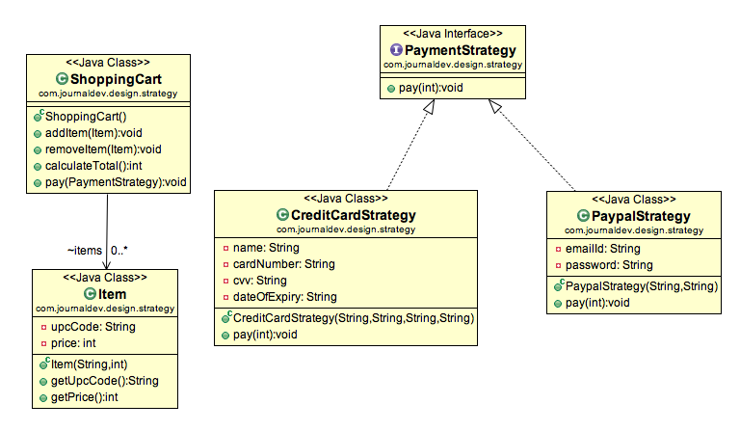
First of all we will create the interface for our strategy pattern example, in our case to pay the amount passed as argument.
PaymentStrategy.java:
package com.journaldev.design.strategy;
public interface PaymentStrategy {
public void pay(int amount);
}
Now we will have to create concrete implementation of algorithms for payment using credit/debit card or through paypal.
CreditCardStrategy.java:
package com.journaldev.design.strategy;
public class CreditCardStrategy implements PaymentStrategy {
private String name;
private String cardNumber;
private String cvv;
private String dateOfExpiry;
public CreditCardStrategy(String nm, String ccNum, String cvv, String expiryDate){
this.name=nm;
this.cardNumber=ccNum;
this.cvv=cvv;
this.dateOfExpiry=expiryDate;
}
@Override
public void pay(int amount) {
System.out.println(amount +" paid with credit/debit card");
}
}
PaypalStrategy.java:
package com.journaldev.design.strategy;
public class PaypalStrategy implements PaymentStrategy {
private String emailId;
private String password;

public PaypalStrategy(String email, String pwd){
this.emailId=email;
this.password=pwd;
}
@Override
public void pay(int amount) {
System.out.println(amount + " paid using Paypal.");
}
}
Item.java:
package com.journaldev.design.strategy;
public class Item {
private String upcCode;
private int price;
public Item(String upc, int cost){
this.upcCode=upc;
this.price=cost;
}
public String getUpcCode() {
return upcCode;
}
public int getPrice() {
return price;
}
}

ShoppingCart.java:
package com.journaldev.design.strategy;
import java.text.DecimalFormat;
import java.util.ArrayList;
import java.util.List;
public class ShoppingCart {
//List of items
List<Item> items;
public ShoppingCart(){
this.items=new ArrayList<Item>();
}
public void addItem(Item item){
this.items.add(item);
}
public void removeItem(Item item){
this.items.remove(item);
}
public int calculateTotal(){
int sum = 0;
for(Item item : items){
sum += item.getPrice();
}
return sum;
}

public void pay(PaymentStrategy paymentMethod){
int amount = calculateTotal();
paymentMethod.pay(amount);
}
}
ShoppingCartTest.java:
package com.journaldev.design.strategy;
public class ShoppingCartTest {
public static void main(String[] args) {
ShoppingCart cart = new ShoppingCart();
Item item1 = new Item("1234",10);
Item item2 = new Item("5678",40);
cart.addItem(item1);
cart.addItem(item2);
//pay by paypal
cart.pay(new PaypalStrategy("myemail@example.com", "mypwd"));
//pay by credit card
cart.pay(new CreditCardStrategy("Pankaj Kumar", "1234567890123456", "786", "12/15"));
}
}
Output:
50 paid using Paypal.
50 paid with credit/debit card
b) Observer Design Pattern
Observer design pattern is useful when you are interested in the state of an object and want to get notified whenever there is any change. In observer pattern, the object that watch on the state of another object are called Observer and the object that is being watched is called Subject.
Subject contains a list of observers to notify of any change in it’s state, so it should provide methods using which observers can register and unregister themselves. Subject also contain a method to notify all the observers of any change and either it can send the update while notifying the observer or it can provide another method to get the update.
Observer should have a method to set the object to watch and another method that will be used by Subject to notify them of any updates.
Java provides inbuilt platform for implementing Observer pattern through java.util.Observable class and java.util.Observer interface. However it’s not widely used because the implementation is really simple and most of the times we don’t want to end up extending a class just for implementing Observer pattern as java doesn’t provide multiple inheritances in classes.
Java Message Service (JMS) uses Observer design pattern along with Mediator pattern to allow applications to subscribe and publish data to other applications.
Model-View-Controller (MVC) frameworks also use Observer pattern where Model is the Subject and Views are observers that can register to get notified of any change to the model.
c) Iterator Design Pattern
This pattern is used to get a way to access the elements of a collection object in sequential manner without any need to know its underlying representation.
We're going to create a Iterator interface which narrates navigation method and a Container interface which retruns the iterator . Concrete classes implementing the Container interface will be responsible to implement Iteratorinterface and use it
IteratorPatternDemo, our demo class will use NamesRepository, a concrete class implementation to print a Names stored as a collection in NamesRepository.
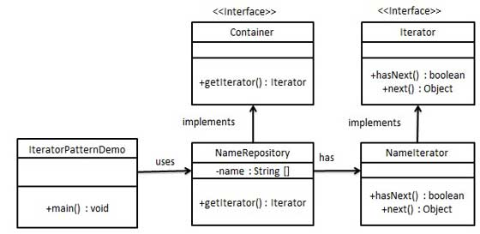

Step 1
Create interfaces.
Iterator.java
public interface Iterator {
public boolean hasNext();
public Object next();
}
Container.java
public interface Container {
public Iterator getIterator();
}

Step 2
Create concrete class implementing the Container interface. This class has inner class NameIterator implementing the Iterator interface.
NameRepository.java
public class NameRepository implements Container {
public String names[] = {"Robert" , "John" ,"Julie" , "Lora"};

@Override
public Iterator getIterator() {
return new NameIterator();
}
private class NameIterator implements Iterator {
int index;
@Override
public boolean hasNext() {
if(index < names.length){
return true;
}
return false;
}
@Override
public Object next() {
if(this.hasNext()){
return names[index++];
}
return null;
}
}
}

Step 3
Use the NameRepository to get iterator and print names.
IteratorPatternDemo.java
public class IteratorPatternDemo {
public static void main(String[] args) {
NameRepository namesRepository = new NameRepository();
for(Iterator iter = namesRepository.getIterator(); iter.hasNext();){
String name = (String)iter.next();
System.out.println("Name : " + name);
}
}
}

Step 4
Verify the output.
Name : Robert
Name : John
Name : Julie
Name : Lora

d) Template Method Design Pattern
Template method defines the steps to execute an algorithm and it can provide default implementation that might be common for all or some of the subclasses.
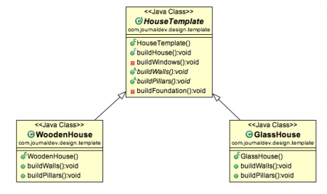
Let’s understand this pattern with an example, suppose we want to provide an algorithm to build a house. The steps need to be performed to build a house are – building foundation, building pillars, building walls and windows. The important point is that the we can’t change the order of execution because we can’t build windows before building the foundation. So in this case we can create a template method that will use different methods to build the house.
HouseTemplate.java
package com.journaldev.design.template;
public abstract class HouseTemplate {
//template method, final so subclasses can't override
public final void buildHouse(){
buildFoundation();
buildPillars();
buildWalls();
buildWindows();
System.out.println("House is built.");
}
//default implementation
private void buildWindows() {
System.out.println("Building Glass Windows");
}
//methods to be implemented by subclasses
public abstract void buildWalls();
public abstract void buildPillars();
private void buildFoundation() {
System.out.println("Building foundation with cement,iron rods and sand");
}
}
buildHouse() is the template method and defines the order of execution for performing several steps
WoodenHouse.java
package com.journaldev.design.template;
public class WoodenHouse extends HouseTemplate {
@Override
public void buildWalls() {
System.out.println("Building Wooden Walls");
}
@Override
public void buildPillars() {
System.out.println("Building Pillars with Wood coating");
}
}

GlassHouse.java
package com.journaldev.design.template;
public class GlassHouse extends HouseTemplate {
@Override
public void buildWalls() {
System.out.println("Building Glass Walls");
}
@Override
public void buildPillars() {
System.out.println("Building Pillars with glass coating");
}
}

HousingClient.java
package com.journaldev.design.template;
public class HousingClient {
public static void main(String[] args) {
HouseTemplate houseType = new WoodenHouse();
//using template method
houseType.buildHouse();
System.out.println("************");

houseType = new GlassHouse();
houseType.buildHouse();
}
}
Output :
Building foundation with cement,iron rods and sand
Building Pillars with Wood coating
Building Wooden Walls
Building Glass Windows
House is built.
************
Building foundation with cement,iron rods and sand
Building Pillars with glass coating
Building Glass Walls
Building Glass Windows
House is built

